Hello and Welcome to the SSM Health St. Joseph – Lake St. Louis Family!

As President of SSM Health St. Joseph – Lake Saint Louis, I am thrilled to officially welcome you to our team! We are incredibly excited to have you join us and contribute to our Mission of providing exceptional healthcare and compassionate care to our community. SSM Health St. Joseph – Lake Saint Louis is a place where we value teamwork, innovation, and a commitment to excellence, and we believe your unique skills and perspectives will be invaluable to our organization.

Established in 1986, SSM Health St. Joseph - Lake Saint Louis offers residents of western St. Charles, Lincoln, and Warren Counties exceptional health care close to home. Our 216-bed hospital is a state-designated Level III Trauma Center, a Level II Time Critical Diagnosis STEMI Center and specializes in obstetric and pediatric care, as well as many other specialties.

Inspired by our founding religious sisters, we value the sacredness and dignity of each person. Therefore, we find these five values consistent with our heritage and ministry:

- Compassion: We reveal the healing presence of God through compassionate care focused on the fullness of the person.
- Respect: We respect life at all stages and promote the dignity and well-being of every person.
- Excellence: We provide exceptional care and service through employees and physicians dedicated to our Mission.
- Stewardship: We use financial, human and natural resources responsibly and care for the environment.
- Community: We cultivate relationships that inspire service and promote justice in our organization and throughout our communities, with special concern for the poor and marginalized.

As we embark on this new journey together, we will embrace SSM Health’s Quality Principles of: Patients and other customers are our first priority, quality is achieved through people, all of our work is part of a process, decision-making by facts, and quality requires continuous quality improvement.

I would like to introduce you to our Hospital Campus Executive Team. We are a collaborative team with the goal of providing you the support you need to contribute to our Mission while achieving exceptional care for all our patients.

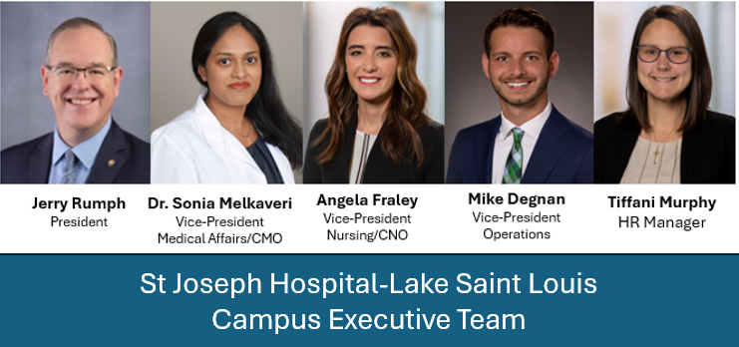

To ensure patients and visitors have adequate parking, employees are asked to park in designated employee parking areas. Here is a copy of our campus map with all the approved employee parking lots: SJ-LSL Parking Map.

I am confident that you will find your new role here at St. Joseph – Lake Saint Louis to be both professionally challenging and rewarding. I am excited to see the positive impact you will make on our patients, your coworkers and our community. Welcome to the Lake family!

Sincerely,

Jerry Rumph, MHA, FACHE
President

©2021 SSM Health. All rights reserved. SYS-SYS-15-104888 5/21

